AQ-1 System Architecture & Engineering Design
  - Technical Artefact 1

1. Project Scope & Requirements

1.1 Project purpose and context
AQ-1 is a proposed secure water-quality monitoring and control system for Coral Coast Aquaculture, a fictional prawn and barramundi farm. The design addresses three outdoor ponds and focuses on temperature, dissolved oxygen (DO) and pH as essential water-quality measurements. Trusted readings are intended to support operator awareness and safe operation of farm equipment, including aerators, pumps and feeders. The system must also identify missing or altered readings so that unreliable data cannot silently influence operational decisions.
This artefact documents the engineering design for the complete reference farm. The university prototype implements a narrower demonstration of selected monitoring, messaging and security functions rather than a full commercial installation. The precise as-built configuration, including the physical temperature sensor, is documented separately in the Prototype Implementation artefact. Proposed functions are not treated as tested capabilities unless supported by implementation evidence.

1.2 Reference farm and operating assumptions
The reference farm comprises Pond A and Pond B for prawns and Pond C for barramundi. Each pond is assumed to be approximately 50 m × 30 m with an average depth of 1.5 m. Two monitoring stations are proposed per pond: one near the inlet or boundary and another toward the central or aeration area. Each station measures temperature, DO and pH, resulting in six stations and 18 measurement points across the full design. Two locations per pond were selected to provide better spatial coverage than a single measurement location.
For planning purposes, the greatest assumed pond-to-control-room distance is approximately 200 m, with up to 150 m between pond areas. These are reference assumptions, not surveyed site measurements; they inform later network, cabling and gateway decisions. Outdoor hardware must account for moisture, dust, corrosion, variable temperatures and protected power and cable terminations. The design assumes a local control room and private farm network, with internet connectivity optional for remote monitoring.
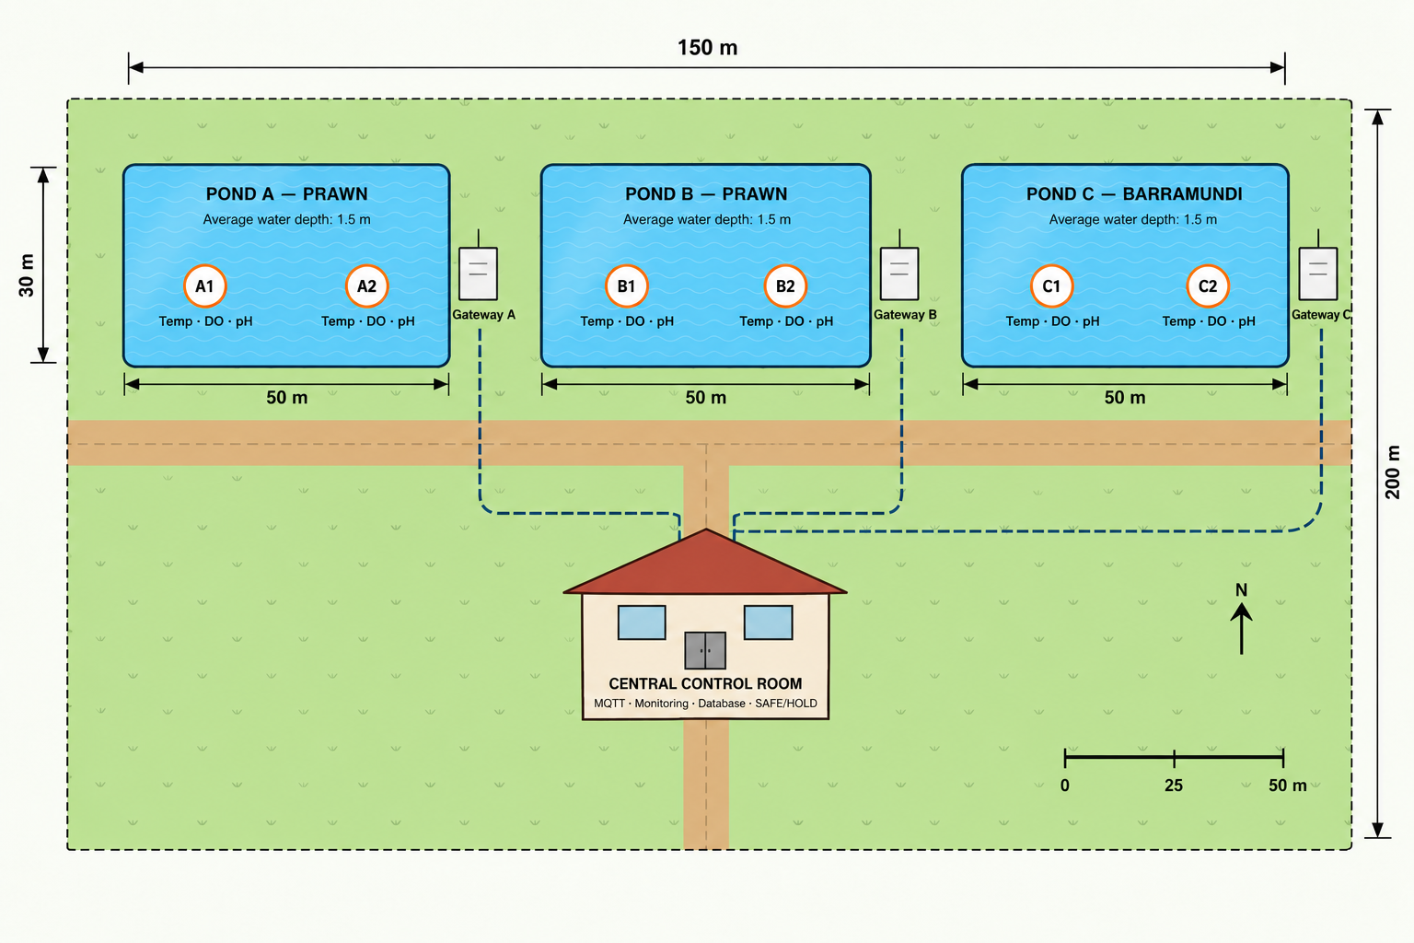
Figure 1: Proposed AQ-1 farm layout showing three ponds, monitoring stations, gateways and central control room.

1.3 Functional and operational requirements
The complete system is designed to collect identifiable, timestamped water-quality readings, transfer them through MQTT, validate them before use, and present trusted data and system status to authorised operators. The original design proposes a nominal 30-second reporting interval, subject to equipment and operating requirements. A central monitoring function should maintain a separate last-valid-reading time for each sensor, alert on abnormal conditions and detect sensor or communication outages.
The design also includes equipment-status monitoring and a SAFE/HOLD state for conditions where essential trusted data are unavailable. Normal automatic operation must not continue solely on missing, outdated or unverified measurements. Recovery should occur only after defined conditions have been satisfied; abnormal readings should be evaluated using suitable thresholds and validation rather than causing immediate unsafe actions.

1.4 Security and availability requirements
Each sensor and system component must have a distinct identity. MQTT clients are intended to authenticate, and authorised publishing and subscribing actions should be restricted to the appropriate topics. HMAC-SHA256 is specified to detect unauthorised message modification; the wider design also calls for message freshness checks to resist replay, TLS where supported, protected credentials, network separation and audit logging. The monitoring service should reject malformed, unauthorised or invalid messages without allowing them to refresh a sensor’s last-valid-reading time.
Availability and safety are linked: local monitoring, outage detection and SAFE/HOLD decisions must remain operable during internet or optional cloud-service failures. An isolated, authorised test environment is required for spoofing, tampering, replay and outage experiments. These requirements describe the intended security architecture; implementation and verification status are assessed in the dedicated cybersecurity and testing artefacts.

1.5 Scope boundaries and design rationale
The project does not construct three operational ponds, install industrial electrical equipment or control real farm machinery. The commercial design specifies an intended architecture and equipment approach, while the prototype evaluates selected communication, integrity-verification, monitoring and failure-response behaviours. The source design originally proposed a GNS3-based simulation; the later implementation uses a different virtualisation arrangement and includes a physical temperature sensor. This difference will be recorded explicitly rather than retroactively changing the original design rationale.
A local-first architecture was chosen so that essential monitoring and safety responses do not depend on external cloud connectivity. MQTT was selected to decouple sensor publishers from monitoring subscribers, while independent sensor identities and per-sensor freshness tracking support fault detection. The three-pond, two-station reference model provides a repeatable basis for sizing and extending the design, even though the implemented prototype covers only a subset of it. (OASIS 2019).

1.6 Requirements traceability
The detailed requirement identifiers in the original AQ-1 design documentation remain the baseline for traceability. The following summary groups those requirements by engineering objective; subsequent artefacts will identify which requirements were implemented and tested.
Requirement group | Design intent
Water-quality monitoring | Temperature, DO and pH at two stations per pond; identifiable and timestamped readings.
Trusted data handling | MQTT transport, validation before acceptance, rejection and logging of invalid messages.
Operator visibility | Dashboard information for readings, sensor availability, alerts and equipment/control state.
Safety and continuity | Outage detection, SAFE/HOLD, controlled recovery and local operation during internet failure.
Security and testing | Identity, HMAC integrity, proposed access controls and isolated authorised attack testing.

2. Overall System Architecture

2.1 Architecture approach
AQ-1 adopts a distributed, local-first architecture in which each pond has its own monitoring stations and edge gateway, while central services receive, validate and display water-quality information. This arrangement separates field acquisition from central supervision and allows the complete three-pond design to be expanded pond by pond. The local-first approach was selected because essential monitoring and protective decisions should not depend on internet availability. Optional cloud connectivity is intended for remote visibility rather than as the sole path for safe operation.
Figure 1 in Section 1 establishes the physical reference layout. Ponds A and B support prawns, while Pond C supports barramundi. Each pond has two stations measuring temperature, dissolved oxygen (DO) and pH. Three dedicated gateways aggregate the six stations, giving 18 planned measurement streams across the reference farm. The distances and locations shown in Figure 1 are design assumptions rather than surveyed installation measurements.

2.2 Logical components and data flow
At the field layer, sensor nodes acquire water-quality measurements and associate them with a sensor identity and measurement time. The pond gateway forms the boundary between field devices and the farm network, providing a controlled point for message processing and forwarding. MQTT was chosen for transport because its publish/subscribe model decouples individual sensor publishers from monitoring consumers and supports adding further stations without tightly coupling applications to field devices. (OASIS 2019).
At the central layer, an MQTT broker routes sensor messages to authorised consumers. A verification and monitoring service evaluates message structure, origin and integrity before readings are treated as trusted. The monitoring layer maintains sensor status, records events and supplies validated information to the operator dashboard. Control decisions are designed to use trusted, sufficiently recent readings rather than raw incoming MQTT messages. These responsibilities are deliberately separated so that receiving a message is not equivalent to accepting its measurement.
Logical data flow of the proposed AQ-1 architecture
Monitoring stations (temperature · DO · pH) — two per pond, three ponds
↓
Pond edge gateways A / B / C
↓
Private farm network → Local MQTT broker
↓
Message verification and monitoring → Trusted readings / alerts
↓
Node-RED / operator interface | Local control and SAFE/HOLD
Optional remote/cloud view (non-essential to local safety)

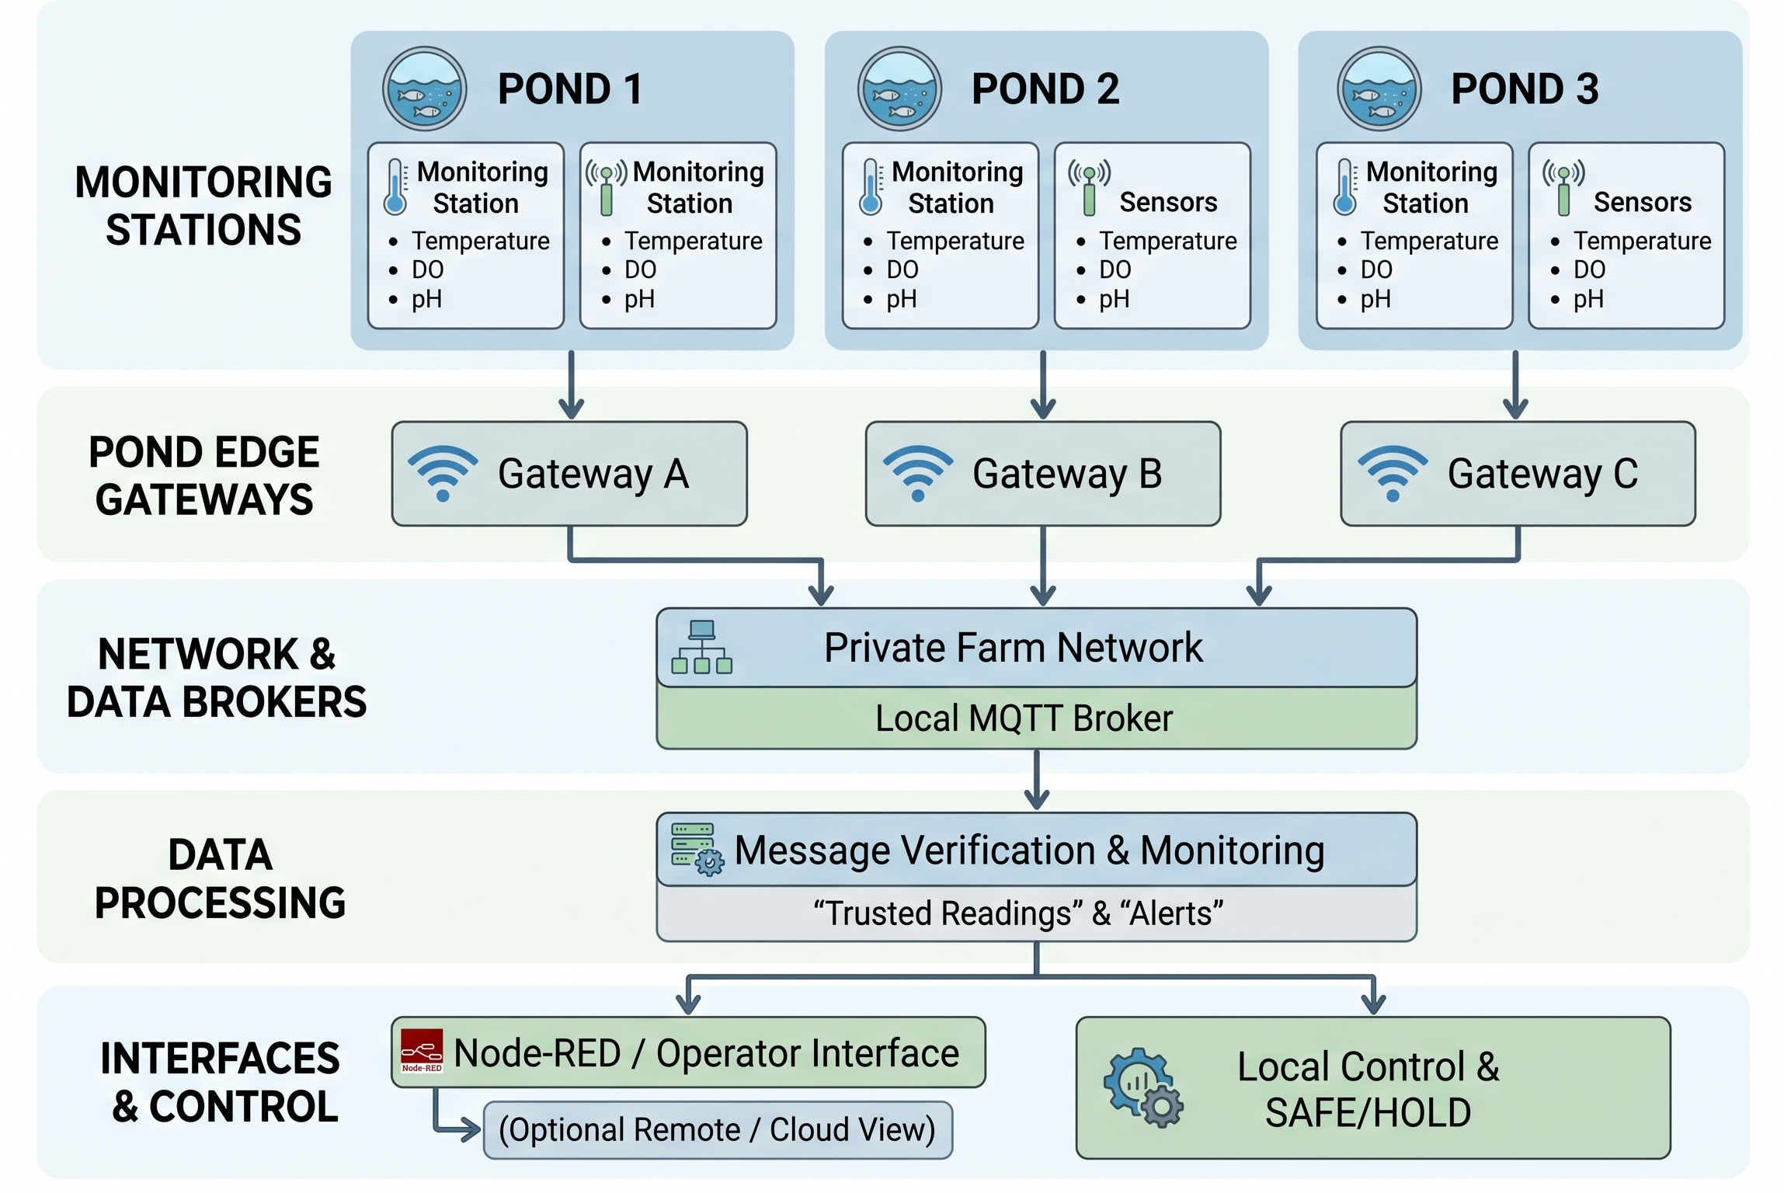
Figure 2: Proposed AQ-1 monitoring, gateway, verification and control architecture.

2.3 Farm network and deployment boundaries
The proposed farm network connects the three pond gateways to services located in the central control room. The design separates field equipment, broker and monitoring services, operator access and optional internet-facing functions as distinct security and operational boundaries. Protected wired or other suitable private backhaul is preferred for the reference distances; the exact medium, routing and equipment must be selected against installation conditions and verified before physical deployment. Network segmentation and restricted broker permissions are part of the proposed security design, not evidence that every control has been configured in the prototype.
Central MQTT, monitoring and control functions are intended to remain available locally when an external connection fails. The wider design also considers broker resilience, power continuity and recovery; detailed security mechanisms and failure handling are addressed in Sections 5 and the dedicated technical artefacts. Cloud integration, where used, should not be allowed to bypass local validation or protective control behaviour.

2.4 Monitoring, control and safety boundaries
The monitoring subsystem is responsible for presenting accepted readings, their freshness and the health of each station. Node-RED was selected in the design as a practical dashboard and integration platform for displaying live sensor status and alerts. Historical storage and operator access are planned as central services. A dashboard indication is informational: it does not, by itself, establish that a sensor value is safe or that a control command is authorised. (OpenJS Foundation n.d.).
The proposed control layer manages equipment such as aerators, pumps and feeders using defined operating rules and verified data. SAFE/HOLD is intended to prevent unsafe automatic actions when essential readings are missing, stale or untrusted. The separation between monitoring and control is a deliberate safety decision: loss of dashboard visibility or optional cloud access should not force equipment into an uncontrolled state. Detailed thresholds, watchdog timing and recovery conditions belong in the control and fail-safe design rather than being repeated in this architecture overview.

2.5 Proposed architecture versus implemented prototype
The full architecture represents the intended farm-scale engineering solution. The university prototype implements only a selected slice to demonstrate sensor messaging, gateway-side integrity verification, monitoring and attack/failure scenarios. The implementation uses VMware-based virtual machines and simulated DO/pH sources alongside a physical temperature sensor, whereas the earlier design documentation described a GNS3-oriented simulation. This difference is retained explicitly to distinguish original design decisions from the eventual build.
Full reference design | Prototype scope / evidence boundary
Three ponds; six stations; 18 measurement streams | Selected demonstration streams; not a full three-pond installation
Industrial sensor-node and gateway deployment | Simulated DO/pH and physical temperature sensor; final wiring and integration documented separately
Private farm network with central MQTT services | Virtualised network and MQTT messaging; final configuration documented in Artefact 2
Integrated monitoring, control and resilience | Selected dashboard, verification and failure-response demonstrations; only tested functions claimed
The implementation artefact records the as-built topology, software versions, physical sensor details, configurations and screenshots. The cybersecurity and validation artefacts separately report what was actually tested and the observed outcomes. This division prevents planned capabilities—such as full broker redundancy, cloud operation or industrial equipment control—from being mistaken for completed features.

3. Sensor Nodes & Communication Design

3.1 Monitoring station arrangement
The reference design places two monitoring stations at each of the three ponds. Each station includes temperature, dissolved oxygen (DO) and pH measurement functions, giving six stations and 18 planned measurement streams. The paired locations are intended to capture differences across a pond rather than relying on a single sampling point. Sensor identities and pond/station identifiers allow measurements and faults to be traced to their source. The 30-second nominal reporting interval provides regular visibility without requiring continuous transmission; the final interval would need to be checked against sensor response, power consumption and farm operating conditions.

3.2 Sensor selection and engineering considerations
Temperature is included because it influences aquatic conditions and the interpretation of other water-quality measurements. The full design calls for a protected, water-suitable probe connected to a field controller. DO monitoring is necessary because insufficient oxygen can quickly affect stock welfare and aeration decisions; the proposed industrial probe must support reliable measurement and calibration in wet conditions. pH monitoring identifies changes in water chemistry that may require operator attention. For DO and pH, calibration, probe maintenance and suitable signal interfaces are more important than selecting hardware solely by purchase price. Exact commercial models and specifications remain design selections, not claims of hardware installed in the prototype.

Measurement | Design purpose | Practical design consideration
Temperature | Track water temperature at each station | Waterproof probe, stable interface and outdoor protection
Dissolved oxygen | Detect oxygen conditions relevant to aeration | Calibration, probe maintenance and measurement reliability
pH | Monitor water chemistry and abnormal changes of quality | Calibration, probe care and appropriate electrical interface
The implemented demonstration differs from this full sensor-node design: DO and pH are generated by Python simulators, while a physical temperature sensor is included. The physical sensor model, electrical connections, firmware and observed readings will be specified in Artefact 2 after verification against the completed build.

3.3 Field acquisition and gateway interface
Each monitoring station is designed to acquire a reading, associate it with its source identity and measurement type, and forward it through the pond gateway. One gateway per pond reduces the need for every sensor to communicate directly with the control room and provides a defined boundary for field-device traffic. Gateway processing is intended to check message format and security information before data is accepted downstream. Separating acquisition from validation also allows a faulty or unauthorised sensor message to be rejected without affecting readings from other stations.

3.4 MQTT messaging and data structure
MQTT was selected for its lightweight publish/subscribe model and its ability to distribute readings to monitoring services without direct point-to-point connections. The proposed topic structure distinguishes ponds, sensor types and sources so that consumers can subscribe only to relevant data. Sensor messages should include a unique source identifier, measurement type, value and a timestamp or equivalent freshness information. Integrity metadata is carried with the message where HMAC verification is used. Topic permissions, transport encryption and replay protection are design requirements that must be distinguished from the controls actually configured and tested. (OASIS 2019).
In the prototype, sensor publishers and a Python gateway exchange JSON messages through MQTT, with HMAC-SHA256 used to check message integrity. The specific topic names, field formats and broker settings used in the final integrated build are recorded with the source code and deployment instructions rather than duplicated in this design overview.

3.5 Message validation and communication failures
A received MQTT publication is not automatically a trusted measurement. The verification service is designed to check required fields, source identity, integrity and freshness before updating the last-valid-reading time for that sensor. Invalid messages should be rejected and logged without refreshing availability status. If expected trusted readings stop arriving, the monitoring service should flag the affected source and notify the control layer so that the defined SAFE/HOLD response can be considered. Detailed attack cases, outage timings and observed results are documented in the dedicated security and validation artefacts.

3.6 Design trade-offs and implementation boundary
Distributed stations and per-pond gateways provide clearer fault isolation and an expandable architecture, but require more field hardware, protected power and maintenance than a single central sensor. MQTT simplifies data distribution but requires separate controls for trust and authorisation. These choices support the reference farm design; they do not imply that all six stations, three gateways or industrial probes were physically deployed. The smaller prototype tests selected sensing, communication and verification functions and is described separately as an as-built system.

4. Gateway, Monitoring & Control Design

4.1 Pond gateway responsibilities
The reference architecture assigns one edge gateway to each pond to consolidate readings from its two monitoring stations before forwarding data over the private farm network. This per-pond arrangement limits field-side dependencies, provides a defined point for device identification and message handling, and permits faults to be investigated by pond. Gateway hardware and communications must be selected for the outdoor distances and environmental conditions established in Section 1; the design does not assume that a commercial gateway has been installed in the university prototype.
A gateway should distinguish message reception from successful validation. Incoming records require checks for required fields, permitted sensor identities and integrity metadata before they are released as trusted readings. Rejected records should be logged with a reason while leaving the last-valid timestamp unchanged. This prevents a stream of malformed or forged traffic from disguising a genuine sensor outage.

4.2 Central MQTT and monitoring services
A locally hosted MQTT broker provides publish/subscribe message distribution between pond gateways and central services. Keeping the broker on the farm network allows routine monitoring to continue without an internet connection. The monitoring service maintains the latest accepted value, measurement time, availability state and relevant alerts for each source. These functions are separated from the broker because delivery of an MQTT publication does not establish that its contents are authentic or safe to use. (Eclipse Foundation n.d.).
The design anticipates historical records and event logs to support maintenance and incident review. Data retention, database selection and broker redundancy would be determined during production engineering. The prototype uses MQTT and Python-based verification, but production-scale storage and high availability must not be inferred from the demonstration.

4.3 Operator dashboard and alarm presentation
Node-RED is proposed as the operator-facing monitoring platform because it can subscribe to system events and present sensor values, trends and status with relatively little custom interface development. The dashboard should distinguish accepted readings from rejected messages, identify the pond and station concerned, and make stale or offline sensors visible. A missing reading should not be silently replaced with an apparently current value. Operator displays provide situational awareness, while safety decisions remain governed by the separate control logic. (OpenJS Foundation n.d.).

4.4 Equipment control and operating boundaries
The complete farm design considers aerators, pumps and feeders as controlled equipment. Decisions should use validated measurements, configured thresholds and equipment interlocks rather than direct, unverified sensor publications. Aeration is particularly relevant to dissolved oxygen, while other equipment actions depend on operating schedules and the needs of the farm. Exact control thresholds and actuator interfaces require site-specific approval; they are not presented here as commissioned settings.
The SAFE/HOLD concept prevents automatic control from continuing on missing or untrusted essential data. Its purpose is to maintain a predefined conservative operating state and alert an operator until trustworthy readings and recovery conditions are restored. The intended response depends on equipment type: a single universal on/off command would not be appropriate for every pump, aerator or feeder. Detailed failure-state rules are addressed in Section 5.

4.5 Design boundary
The reference design specifies three pond gateways and a central monitoring/control arrangement. The prototype instead demonstrates selected publishers, MQTT messaging, gateway-side HMAC verification and monitoring functions using virtual machines and a physical temperature sensor. The exact as-built software distribution, dashboard screens and any exercised control outputs are recorded in Artefact 2 and validated in Artefact 5.

5. Security & Fail-Safe Design

5.1 Security objectives and trust boundaries
The main security objective is to prevent altered, unauthorised or stale water-quality messages from being treated as reliable input to monitoring and control. Trust boundaries exist between field sensors and gateways, MQTT publishers and subscribers, the verification service, the operator interface and optional remote access. A private network reduces exposure but does not by itself authenticate sensor data. Consequently, the design uses layered controls rather than relying on network location alone.

5.2 Message integrity and source authentication
HMAC-SHA256 was selected to detect message alteration and to provide authentication to parties holding the correct shared secret. The receiving service recomputes the authentication code over a consistently defined message representation and compares it with the transmitted value before accepting the reading. This is lightweight enough for the proposed sensor-messaging workflow and directly addresses forged or tampered measurement values. It does not provide confidentiality, and compromised shared keys remain a risk; key storage and rotation therefore require separate attention. (National Institute of Standards and Technology 2008).
The wider design also specifies unique sensor identities, authenticated MQTT clients, topic-level permissions, protected credentials and TLS where supported. These measures restrict access and protect messages in transit, but are design requirements unless the final implementation evidence confirms they were configured. Timestamp and sequence-based freshness checks are proposed to reduce replay risk; an HMAC-valid old message must not automatically count as a fresh measurement.

5.3 Validation, monitoring and event handling
The verifier should check message format, expected fields, source identity, authentication code and freshness before updating a sensor state. Invalid or unrecognised messages should generate a security event without refreshing the sensor watchdog. Repeated failures should remain visible to the operator and be recorded for analysis. This separation between untrusted traffic and accepted measurements is necessary because an attacker could otherwise keep a sensor apparently online simply by sending rejected packets.

5.4 Outage detection and SAFE/HOLD response
Each sensor requires independent freshness tracking based on its last accepted reading. When a configured timeout is exceeded, the monitoring service should mark the source stale or offline, raise an alert and signal the relevant control logic. The timeout must reflect the nominal reporting interval, expected network delays and operational risk; the design reporting interval of 30 seconds should not be confused with any shorter timeout selected for a laboratory demonstration.
SAFE/HOLD is a controlled response to unavailable or unreliable data, not proof that all farm machinery can safely be stopped. The appropriate action must be specified for each equipment type and operating scenario. Recovery should require valid readings over an appropriate confirmation period and, where necessary, operator approval, rather than an immediate transition triggered by one new message. Local decision-making should continue when optional cloud access is unavailable.

5.5 Security trade-offs and verification boundary
Shared-secret authentication offers practical integrity protection but introduces key-distribution responsibilities. MQTT simplifies integration but requires authentication, authorisation and transport protection to avoid exposing an open message bus. Centralised monitoring improves operator visibility while making service continuity important. The dedicated Cybersecurity Architecture and Security Testing artefacts document the threat analysis, attack procedures and observed evidence; this section defines the intended controls without overstating their implementation.

6. Engineering Decisions & Implementation Scope

6.1 Consolidated design decisions
The following register summarises the principal engineering choices made for the reference system. The justifications are intentionally brief; Sections 1–5 describe their operating context. Status labels distinguish the complete proposed design from functions represented in the narrower university prototype.
Decision | Engineering justification | Scope / status
Three ponds, two stations per pond | Provides repeatable coverage and allows comparison of locations within each pond. | Reference design; not fully deployed
One edge gateway per pond | Groups field traffic and provides a defined processing and fault-isolation boundary. | Reference design
Temperature, DO and pH monitoring | Captures complementary conditions relevant to water quality and operational response. | DO/pH simulated; physical temperature sensor in prototype
MQTT publish/subscribe | Decouples sensor sources from consumers and supports incremental expansion. | Used in prototype
Local-first monitoring | Keeps essential visibility and protective logic independent of optional internet access. | Design principle; full resilience not established
HMAC-SHA256 verification | Detects message modification and supports shared-key source authentication. | Prototype verification demonstrated
Node-RED operator dashboard | Supports integration and visual presentation of live monitoring information. | Prototype integration; details in Artefact 2
Per-sensor watchdog and SAFE/HOLD | Prevents missing or untrusted measurements from silently supporting automatic actions. | Designed; exercised behaviours require test evidence
Layered access controls and freshness checks | Addresses unauthorised MQTT access and replay beyond integrity checking alone. | Design requirements; implementation to verify

6.2 Reference design and prototype implementation
The proposed farm-scale solution consists of six monitoring stations, 18 measurement streams, three pond gateways and a central control room with monitoring and equipment-control functions. It is an engineering reference for a possible deployment, not a record of installed infrastructure. The university build implements a selected vertical slice: simulated DO and pH publishers, a physical temperature sensor, MQTT transport, Python verification and monitoring, and a virtualised test environment. The original design discussed GNS3, while the later build uses VMware-based systems. This change is recorded as an implementation decision rather than silently rewriting the design history.

6.3 Deferred features and limitations
The prototype does not establish that industrial DO/pH probes, all six monitoring stations, three production gateways, farm actuators, cloud integration, broker redundancy or full security hardening have been installed. Nor does the presence of a dashboard demonstrate automatic control of real equipment. Claims of attack resistance, outage handling and SAFE/HOLD behaviour must be tied to reproducible tests and observed results in Artefacts 4 and 5. The physical temperature sensor model, wiring, firmware and measurement evidence will be documented in the as-built implementation artefact.

6.4 Traceability to delivered artefacts
Artefact 2 records the actual prototype components, network configuration and integration evidence. Artefact 3 develops the threat assessment and cybersecurity controls; Artefact 4 reports authorised attack testing; Artefact 5 covers functional, outage and safety validation. Artefact 6 provides the source code and configuration repository, and Artefact 7 explains deployment and reproduction. Together these records allow the complete design to be evaluated without confusing intended capabilities with demonstrated results.

Appendix A. Real-Farm Equipment Selection and Installation Schedule
This schedule consolidates the equipment options and provisional selections recorded in the original AQ-1 engineering design (Stages 2–14). It describes the proposed full three-pond installation, not hardware purchased or installed for the university demonstration. Manufacturer part numbers, compatibility, Australian availability and prices require supplier confirmation before procurement. (Atlas Scientific n.d.; In-Situ n.d.; Moxa n.d.-c).

A.1 Instrument and gateway options
Function | Options considered in source design | Provisional selection and reason | Quantity | Official description / link | Reason for selection
Temperature | Atlas Scientific Industrial PT-1000; In-Situ Aqua TROLL 100; Aqua TROLL 600 | Atlas Scientific Industrial PT-1000 (ENV-50-TEMP): dedicated immersion RTD probe with suitable range; requires RTD-to-Modbus interface. | 6 probes + 6 interfaces | Atlas Scientific  Official website / product page | Class A RTD accuracy; suitable for immersion with an appropriate transmitter.
Dissolved oxygen | In-Situ RDO PRO-X; Endress+Hauser Oxymax COS61D; Hach LDO sc Model 2 | In-Situ RDO PRO-X (0084700): optical DO measurement with integrated RS-485/Modbus field connection. | 6 | In-Situ  Official website / product page | Optical DO measurement reduces routine membrane maintenance; interface to verify.
pH | Aqualabo PHT; In-Situ Aqua TROLL 600; YSI EXO1 | Aqualabo PHT (PF-PH-E-00015): separate digital pH probe, Modbus RS-485, serviceable cartridge. | 6 | Aqualabo  Official website / product page | Digital field measurement with serviceable probe; confirm exact configuration.
Pond gateway | Moxa UC-1222A; Seeed reComputer R1000; Raspberry Pi 4 with RS-485 adapters | Moxa UC-1222A-T-LX: industrial Linux gateway with two serial ports, one for each station bus. | 3 | Moxa  Official website / product page | Industrial Linux and serial connectivity for two station buses.
Central controller | Siemens S7-1200 CPU 1214C; Schneider Modicon M241; WAGO PFC200 | Siemens S7-1200 CPU 1214C AC/DC/Relay: local PLC with proposed nine equipment outputs and expandable control interfaces. | 1 | Siemens  Official website / product page | Industrial PLC for deterministic local interlocks; I/O sizing required.
The temperature RTD-to-Modbus transmitter appears as DNT PR-3000-RTD in the original bill of materials, although earlier design sections describe its exact selection as unresolved. Treat this as a budgetary candidate until RTD wiring, scaling, Modbus compatibility and power are checked. The source also treats all primary device selections as provisional. (Atlas Scientific n.d.; Moxa n.d.-c).

A.2 Network and central services
Equipment / medium | Source-design selection | Quantity / purpose | Official description / link | Reason for selection
Pond fibre converter | Moxa IMC-21A-M-SC | 3; short copper Ethernet from gateway to optical backhaul | Moxa  Official website / product page | Converts Ethernet to fibre for longer, electrically isolated backhaul.
Managed control-room switch | Moxa EDS-408A-3M-SC | 1; three fibre connections and VLAN-capable central switching | Moxa  Official website / product page | Industrial fibre aggregation and VLAN segmentation.
Firewall / router | Netgate 1100 | 1; controlled inter-VLAN and service access, subject to interface-capacity check | Netgate  Official website / product page | Restricts network flows between trust zones; interface count to verify.
Outdoor fibre | Armoured duplex multimode fibre, Pacific Datacom FIB-MM-ARM-200 | 600 m budget allowance across three routes; verify route lengths and optical budget | Supplier verification pending  Product link not verified | Armoured fibre suits exposed routes; optical type and length must match.
Fibre terminations | FibraNet FOB-04-SC and compatible patch leads | 4 termination locations; check connectors and fibre types | Supplier verification pending  Product link not verified | Protects splices and provides maintainable optical terminations.
Central host | Dell PowerEdge R250 | 1; local Mosquitto, monitoring and Node-RED/SQLite host; backup broker independence not established | Dell  Official website / product page | Local server for broker, monitoring and logs; sizing and resilience to verify.
MQTT and dashboard software | Eclipse Mosquitto; Node-RED; SQLite | Local services; configuration and host sizing to be finalised | Eclipse / Node-RED  Official website / product page | Local publish/subscribe and flexible operator visualisation.
The original design chooses a fibre-based star backhaul because the assumed pond-to-control-room distance can reach 200 m, exceeding the normal 100 m copper Ethernet channel limit. Each pond should have a separately managed connection, with appropriate VLAN restrictions and a local MQTT broker. MQTT over TLS, authentication and topic ACLs are intended production controls, not proof that they are active in the demonstration. (Moxa n.d.-a; Moxa n.d.-b). (Moxa n.d.-a; Moxa n.d.-b).

A.3 Power, enclosure, wiring and field accessories
Item | Source-design selection or specification | Quantity / design note | Official description / link | Reason for selection
Gateway cabinets | B&R MONO1208 IP65 enclosure (budgetary selection) | 3; verify size, corrosion exposure, cable entries and heat dissipation | B&R  Official website / product page | Protects field electronics from water and dust; confirm enclosure rating.
Power / UPS | Mean Well DRC-100B module | 3; check exact output voltage, battery-charge profile and load sizing | MEAN WELL  Official website / product page | Provides regulated DC and backup charging; verify battery compatibility.
Backup batteries | CSB EVX1272 12 V VRLA | 6; two per pond in series proposed; verify charger compatibility and autonomy | CSB Battery  Official website / product page | Maintains gateway operation during brief outages; autonomy requires calculation.
Instrument mounting | Custom 316 stainless steel removable bracket sets | 6; one per monitoring station | Custom fabrication  Product link not verified | 316 stainless steel resists corrosion and allows probe servicing.
RS-485 field wiring | Shielded twisted-pair industrial RS-485 cable, labelled terminal blocks, termination and surge protection | Two station buses per pond; cable lengths, shielding, grounding and isolation require design checks | Standards-based specification  Product link not verified | Shielded twisted pair supports robust multidrop field communication.
Field protection | Phoenix Contact TTC-6-TVSD (source BOM), glands and terminations | 3 budgetary sets; verify exact surge-protection function and circuit ratings | Phoenix Contact  Official website / product page | Surge and termination protection for exposed field circuits; rating to verify.
DO cable assemblies | In-Situ 15 m submersible cable, part 0054320 | 6; confirm probe connector and routing | In-Situ  Official website / product page | Submersible compatible cable for remote probes; verify connector.
pH sensor cable | Aqualabo PHT monobloc 15 m cable option | 6; confirm supplier ordering configuration | Aqualabo  Official website / product page | Suitable probe cable length and wet-service interface.
Local outputs | Finder 48.31.7.024.0050 interposing relay assemblies | 10; verify coil/contact ratings and protective interface | Finder  Official website / product page | Interface between PLC outputs and correctly rated control circuits.
Site alarm | Werma 430.200.75 beacon / horn | 1; local SAFE/HOLD indication | WERMA  Official website / product page | Local audible/visual warning independent of dashboard availability.
Real motor installation also requires aerators, circulation pumps and feeders (three of each in the proposed design), correctly sized motor starters or VFDs, contactors, overload protection, emergency isolation, equipment feedback contacts, distribution boards, protective earthing and certified field cabling. The original consolidated bill of materials does not provide selected manufacturers, ratings or quantities for all of these installation items; therefore they are identified as outstanding engineering selections rather than invented purchases. (Finder n.d.; WERMA n.d.).

A.4 Control-room and maintenance provisions
The central control room requires a protected equipment rack or cabinet, suitable AC supply and backup, industrial switch and firewall, broker/monitoring server, PLC, operator display or workstation, and alarm annunciation. Maintenance provisions include three spare RDO sensor caps, three spare Aqualabo Plastogel cartridges and two pH 4/7/10 calibration kits as allowed in the original schedule. Appropriate DO verification materials, temperature-reference checks, cleaning supplies and a documented calibration plan should be confirmed during procurement. (Dell Technologies n.d.; Siemens n.d.; Netgate n.d.).

A.5 Engineering selection status and procurement checks
The selected equipment forms a coherent preliminary reference design, but it is not yet an approved construction package. Before purchase, the team or client must verify instrument order codes, sensor interface registers and supply voltages, two independent RS-485 channels per gateway, termination and cable length, fibre transceiver compatibility, cabinet thermal performance, surge protection, battery runtime, network capacity, PLC-to-motor interfaces and compliance with applicable electrical and site safety requirements. The original design includes indicative AUD costs, but those figures are historical estimates and should not be treated as current supplier quotations. (Moxa n.d.-a; Atlas Scientific n.d.).
The device selections and alternatives above are drawn from the original AQ1.docx design and its Stage 14 bill of materials. This appendix deliberately distinguishes that source-derived proposal from the VMware-based university prototype and from any future procurement approval.
Source verification note: Official links identify manufacturer descriptions or product-family pages, not guaranteed stock availability. Where exact part-number pages were not verified, the table explicitly marks the link as pending or supplies the manufacturer website. All selections remain provisional until technical and procurement checks are completed.

References
Aqualabo n.d., Manufacturer website and product information, <https://www.aqualabo.fr/>.
Atlas Scientific n.d., Industrial PT-1000 temperature probe, Atlas Scientific, <https://atlas-scientific.com/industrial/industrial-pt-1000-temperature-probe/>.
B&R Enclosures n.d., Manufacturer website and product information, <https://www.brenclosures.com.au/>.
CSB Battery n.d., Manufacturer website and product information, <https://www.csb-battery.com/>.
Dell Technologies n.d., Manufacturer website and product information, <https://www.dell.com/>.
Eclipse Foundation n.d., Eclipse Mosquitto, Eclipse Foundation, <https://mosquitto.org/>.
Finder n.d., Manufacturer website and product information, <https://www.findernet.com/>.
In-Situ n.d., Manufacturer website and product information, <https://in-situ.com/>.
MEAN WELL n.d., Manufacturer website and product information, <https://www.meanwell.com/>.
Moxa n.d.-a, IMC-21A Series: Ethernet-to-fiber media converters, Moxa, <https://www.moxa.com/en/products/industrial-network-infrastructure/ethernet-media-converters/ethernet-to-fiber-media-converters/imc-21a-series>.
Moxa n.d.-b, EDS-408A Series: Layer 2 managed switches, Moxa, <https://www.moxa.com/en/products/industrial-network-infrastructure/ethernet-switches/layer-2-managed-switches/eds-408a-series>.
Moxa n.d.-c, UC-1200A Series: Arm-based computers, Moxa, <https://www.moxa.com/en/products/industrial-computing/arm-based-computers/uc-1200a-series>.
National Institute of Standards and Technology 2008, The keyed-hash message authentication code (HMAC), FIPS PUB 198-1, US Department of Commerce, <https://doi.org/10.6028/NIST.FIPS.198-1>.
Netgate n.d., Manufacturer website and product information, <https://www.netgate.com/>.
OASIS 2019, MQTT version 5.0, OASIS Standard, <https://docs.oasis-open.org/mqtt/mqtt/v5.0/mqtt-v5.0.html>.
OpenJS Foundation n.d., Node-RED: Low-code programming for event-driven applications, <https://nodered.org/>.
Phoenix Contact n.d., Manufacturer website and product information, <https://www.phoenixcontact.com/>.
Siemens n.d., Manufacturer website and product information, <https://www.siemens.com/>.
WERMA n.d., Manufacturer website and product information, <https://www.werma.com/>.

